**Join Windows 10 to Domain**

To join a **Windows 10** machine to domain you need to login to the machine as local administrator

First you need to verify that the Windows 10 Client get an **IP Address** from **DHCP**. You can also check if the server is reachable from the client, by using the ping command:

Run **cmd** on search bar and **ping 192.168.100.1.**

After that, change the name of the client to **client1** and restart the computer.

Next step is to join the domain, use domain administrator credentials while joining the machine to domain.

[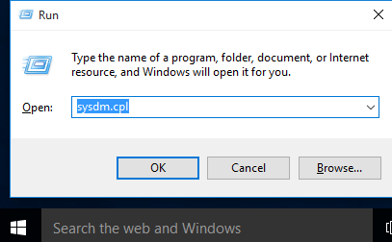](https://www.mustbegeek.com/wp-content/uploads/2020/09/Run.png)

**Step 1.** Logon to Windows 10 machine. Open **Run** application and type **sysdm.cpl**. It will open **System Properties** dialog box.

[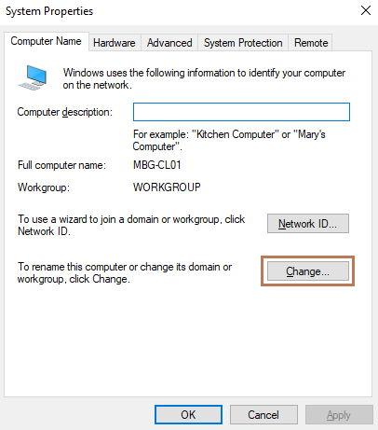](https://www.mustbegeek.com/wp-content/uploads/2020/09/System-Properties.png)

**Step 2.** Under **System Properties**, select **Computer Name** tab and click **Change**.

[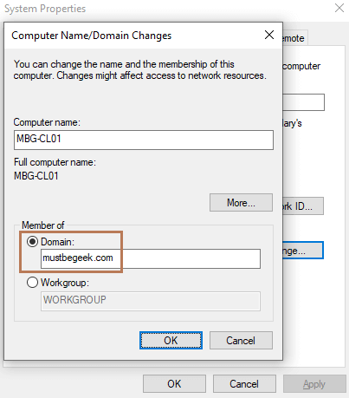](https://www.mustbegeek.com/wp-content/uploads/2020/09/Join-Domain.png)

**Step 3.** In the **Computer Name/Domain Changes** dialog box, choose **Domain** under **Member of** option, remember that your domain is **YourName.local** and enter domain name of your **AD Domain** and click **OK**.

[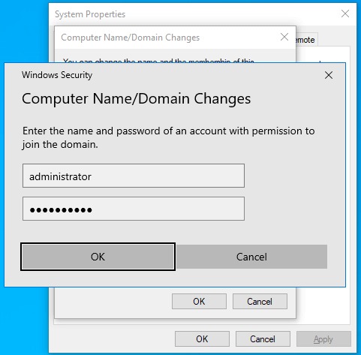](https://www.mustbegeek.com/wp-content/uploads/2020/09/Administrator-Creds.png)

**Step 4.** Enter domain Administrator credential. If you are using any other domain administrator account other than administrator then make sure the user is assigned with **domain admins** rights and click **OK**.

[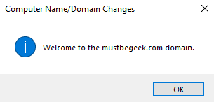](https://www.mustbegeek.com/wp-content/uploads/2020/09/Domain-Joined.png)

**Step 5.** Once you click **OK**, you will get welcome message as shown above. Click **OK**.

[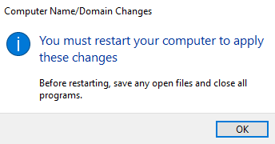](https://www.mustbegeek.com/wp-content/uploads/2020/09/Restart-PC-1.png)

**Step 6.** For the change to take affect you need to restart the PC. Click **OK**

[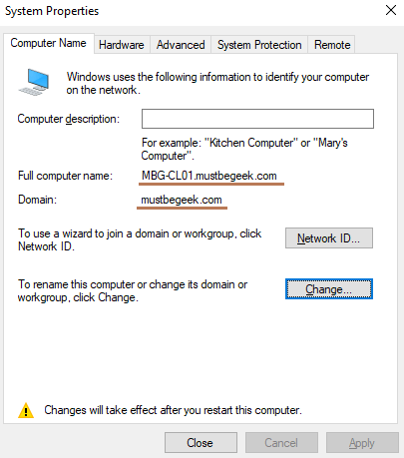](https://www.mustbegeek.com/wp-content/uploads/2020/09/System-Properties-after-Domain-Joined.png)

**Step 7.** You can see the computer name is now FQDN and domain is **YourName.local**. This means the PC is now joined to domain **YourName.local**. Now click **Close**.

[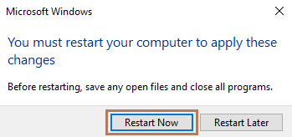](https://www.mustbegeek.com/wp-content/uploads/2020/09/Restart-Now.png)

**Step 8.** Click **Restart Now** to restart the PC. After PC restarts, you can login to the PC with domain user account.

[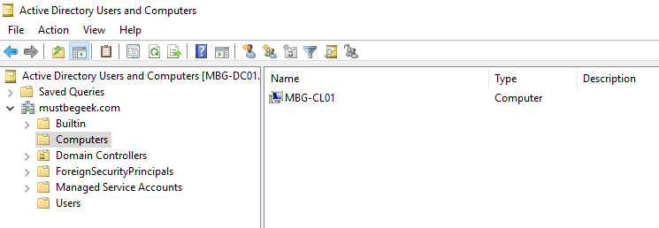](https://www.mustbegeek.com/wp-content/uploads/2020/09/Verify-Domain-Joined-from-AD.png)

You can also verify from domain controller. Open **Active Directory Users and Computers**, expand domain name and select **Computers OU**. You can see the machine from domain controller.